**BDC Practical No. 03**

To implement file management tasks in Hadoop HDFS like adding, retrieving and deleting files.

1. ******HDFS -mkdir Command : Create a directory at given path.**
2. **HDFS -ls command : List the content of the directory.**

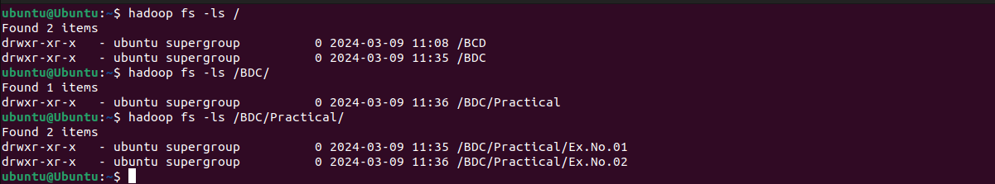

1. **HDFS -put command : Copy file from the local file system to hadoop eco-system.**

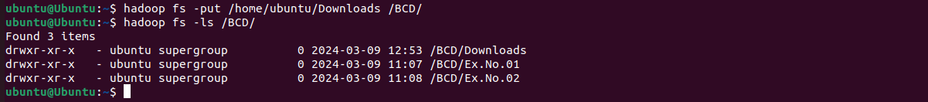

1. **HDFS -get command : Copy file from the hadoop ecosystem to local file system.**

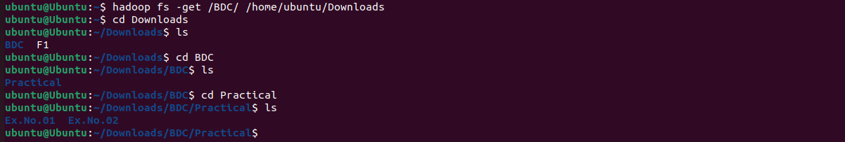

1. 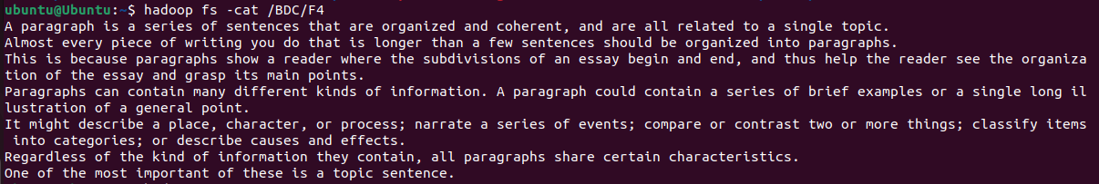**HDFS -cat command : Display content of the file.**
2. **HDFS -cp command : Copy content of the directory.**
3. 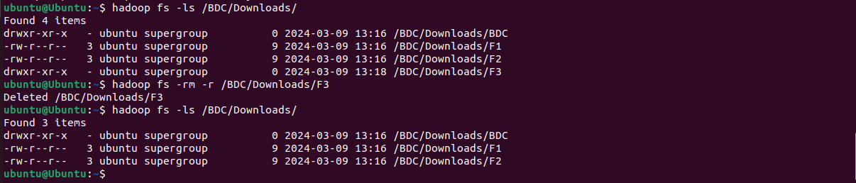**Hadoop -rm command : Remove / Delete a file or directory.**
4. **HDFS -copyFromLocal command : Copy file from the local file system.**
5. **HDFS -copyToLocal command : Copy file to the local file system.**



1. ******HDFS -du command : Display the aggregate length of the file**
2. 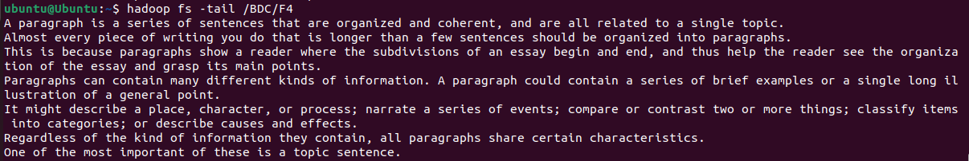**HDFS -tail command : Display last few lines of a file.**